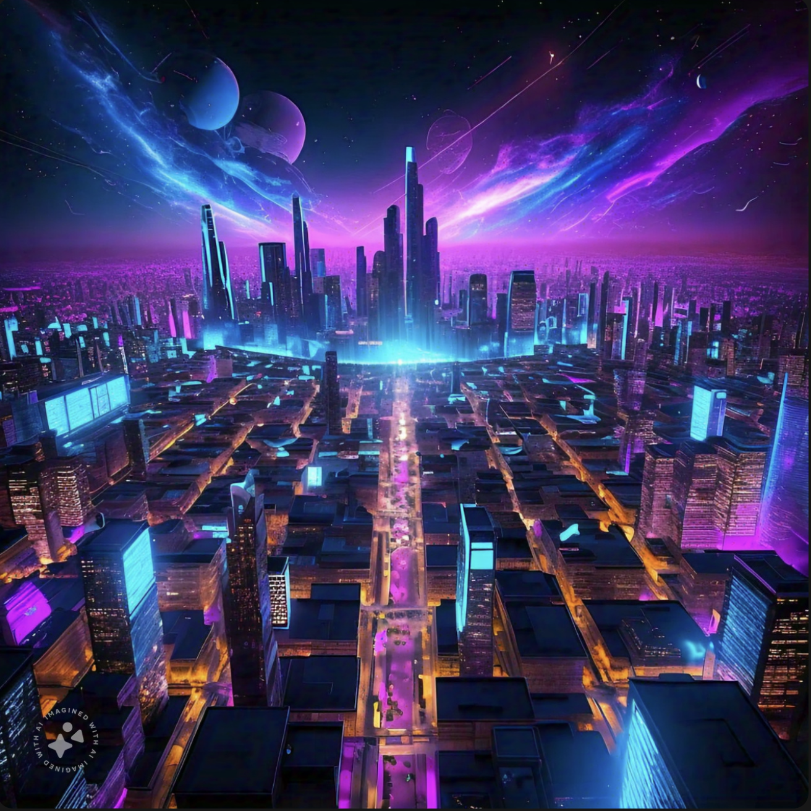

Make a blue and purple cyber city Bird's Eye view with blue to purple galaxy

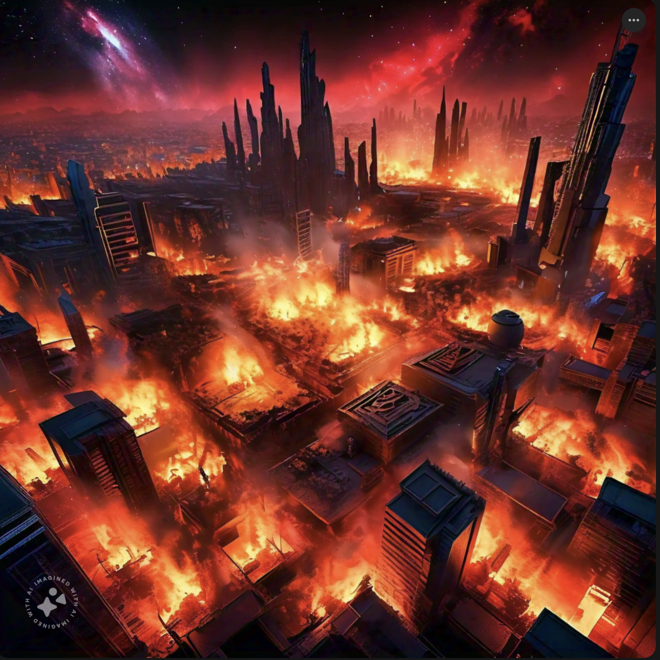 A cyber world city on fire Birds Eye view with red and black background and red and orange galaxy sky